Nombre: ____________________________ Bloque: ________ Fecha: _______________________
Español 1 - Unidad 3 – La cultura – Puerto Rico
Instrucciones: Fill out the following notes sheet based on the cultural activities online. This follows the online activity in order by section. Make sure to hold on to this paper to study, as this information will be part of the exam! This can also be used as a backup should you lose internet connection while working.

Información general:
- The capital of Puerto Rico: ____________________________
- Languages spoken in Puerto Rico: ________________ and ____________________

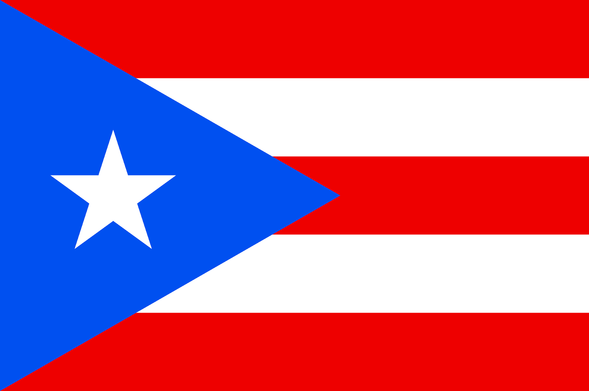
- Currency of Puerto Rico: ____________________________
Colors/Design of the Puerto Rican Flag: ________________________
________________________
- Sea that surrounds Puerto Rico: ____________________________
- Country to the west: ____________________________
- Puerto Ricans are citizens of the _______________________.
- Students in Puerto Rico are required to learn __________________ as a second language in school.
Outdoor Food:
- Families often gather at the beach or park in Puerto Rico to listen to music, hang out, and ___________________________.
- ____________________ are skewers of chicken or pork that are popular at barbecues and snack stands.
Viejo San Juan:
- ________________________ is a colonial quarter/neighborhood in the capital of Puerto Rico with narrow streets and brightly-colored houses.
- All along the narrow streets of this neighborhood you can see ________________________ houses with balconies, from the colonial period.
El Yunque:
- El Yunque is the only ___________________________ in the U.S. Forest Service system.
- ______________________ is the tiny tree frog, a symbol of Puerto Rico, which is named for its distinctive sound.
La Comida:
- Tostones are __________________________, a common side dish in Puerto Rico.
- Cocina criolla is ____________________________ in Puerto Rico.
- Traditional Puerto Rican food is influenced by _________________________________________ cooking styles.
- ________________________ is a condiment mix of onions, bell peppers, cilantro, and garlic which is used a lot in Puerto Rican food.

- ________________________ is a custom where families spend time together after a meal.
La Plaza de Colón:
- You can find plazas, Spanish colonial buildings, and cobblestone streets in ________________________.
- A popular plaza in San Juan is La Plaza Colón where you will see a statue of

_____________________ or Cristóbal Colón.
Politics in Puerto Rico:
- Puerto Rico is __________________________ associated with the United States.
- Puerto Ricans living on the island, cannot vote in _________________________ elections (Puerto Rico does not get electoral votes), but if they move to the mainland they can.
- Puerto Ricans vote to elect their own governor, and local _______________________ and generally have high voter turn out.
- Puerto Rico has __________ main political parties.
Art in Puerto Rico and Peru:
- _________________________ was a Puerto Rican artist born in Brooklyn, New York.
- ___________________ was a Peruvian artist.
- Rafael Tufiño's portraits of his __________________ (such as Goyita) have come to represent all Puerto Rican women.
- Fernando Sayán Polo's painting, Niña campesina sonriente, shows a young girl from Peru wearing typical _____________ clothing.
La Quinceañera:
- A quinceañera is a celebration for a girl's _____________________ birthday party.
- A common Puerto Rican dish eaten at quinceañeras is ________________________.
- Quinceañera dresses often resemble ___________________________.

